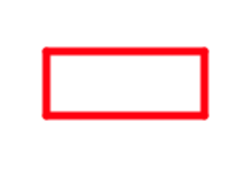Class 12 Project

Name of the Project: Create different shapes using artist lab.

1. Rectangle

Step 1: Move the artist to 50 over, 50 down

Step 2: Set brush color to red

Step 3: Use the move forward and turn right or left code (hint turn by 90 degree)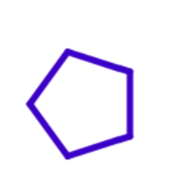

1. Pentagon

Step 1: Move the artist to 50 over, 200 down

Step 2: Set brush color to blue

Step 3: Use the move forward and turn right or left code (hint turn by 72 degree)

1. 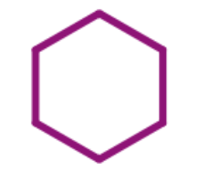Hexagon

Step 1: Move the artist to 50 over, 200 down

Step 2: Set brush color to purple

Step 3: Use the move forward and turn right or left code (hint turn by 60 degree)

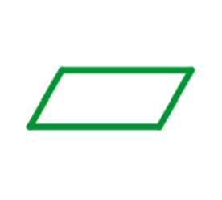

1. Parallelogram

Step 1: Move the artist to 200 over, 300 down

Step 2: Set brush color to green

Step 3: Use the move forward and turn right or left code (hint turn by 60 degree and 120 degree alternatively)

1. 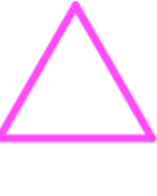Triangle

Step 1: Move the artist to 100 over, 300 down

Step 2: Set brush color to pink

Step 3: Use the move forward and turn right or left code (hint turn by 120 degree)